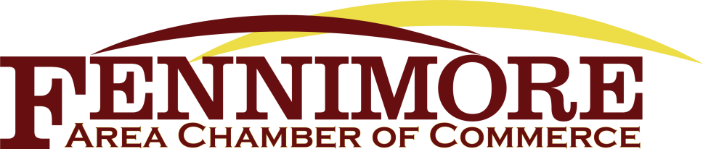

Board Meeting Agenda – Thursday, December 9, 2021
Fennimore Memorial Building, City Council Chambers

Call Meeting to Order – Holly Straka, President

- Consent Agenda – all reports emailed
  - Secretary Report – Ashley Walker
  - Treasurer Report – Sheila Ruchti
  - Committee Reports
- Old Business/Committee Reports
  - Public Relations Board Update – Jessica
  - Membership Committee -Holly/Lori/Jessica
  - Marketing Committee – Ashley/Peggy/Jessica
  - Update from FHS – Mark Kenney
  - Holiday Fen-stival – Jessica
  - Lights in the Park – Jessica
  - Merchandise Sales - Jessica
  - 2022 Holiday Party – Holly
  - Meeting time for 2022
  - 2022 Membership Drive – Jessica
  - 2021 Partnerships – Chamber Presence (Any updates??)
    - City
    - Schools (K-12) & SWTC
    - Ag Community
    - FIEDC
    - GCTC
- New Business
  - Onboarding new Chamber members

Adjourn – Next board meeting - TBD
December Business Spotlight: Serendipity Salon & Day Spa

